University of Engineering and Technology, Lahore
Name: Maria Abbas
Reg No: 2026(S) CYS_61
Department: Computer Engineering
Degree: Cyber security
Section: B
Assignment: PF Lab week 2
Date: 2 March 2026
CLO1

Lab Tasks
For Loops:
Task 1:
This programme counts the total number of vowels and consonants in a user provided string by iterating each character using for loop.

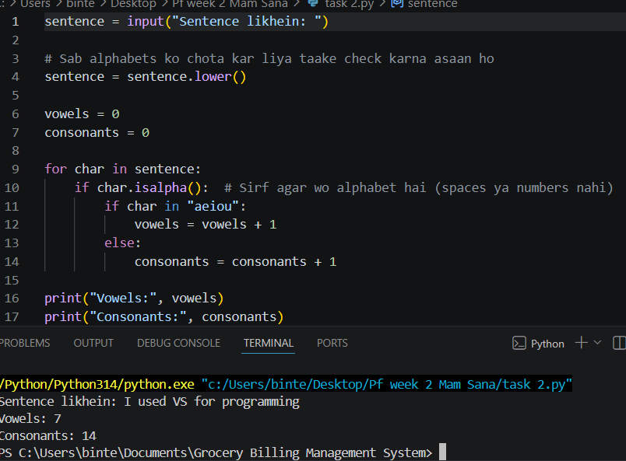

Task 2:
This programme generates a secure password based on custom user preference for length and character type.
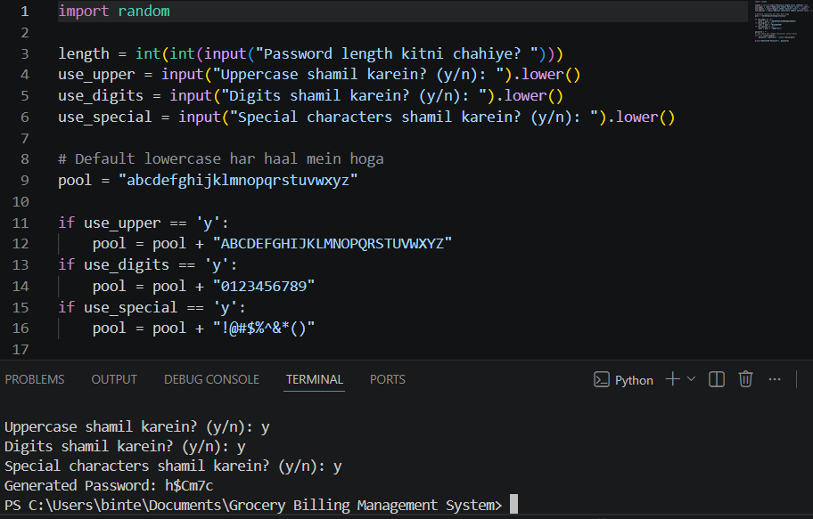
Task 3:
This programme loops through a sequence of numbers from 1 to 5 and print each integers.
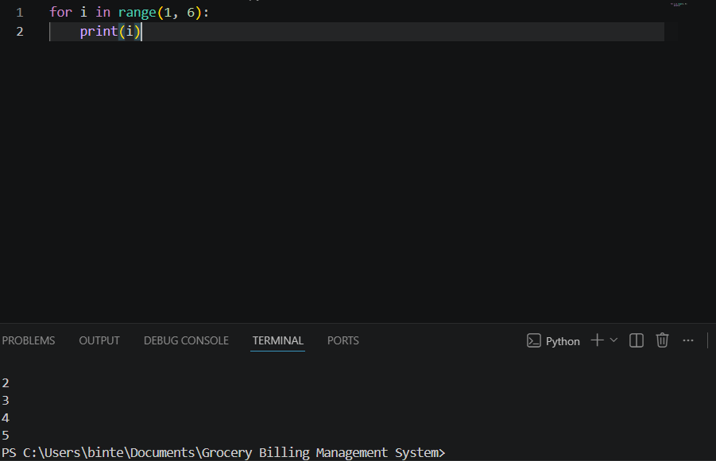

Task 4:
This programme loops through a string variable character by character to print each letter on new line.
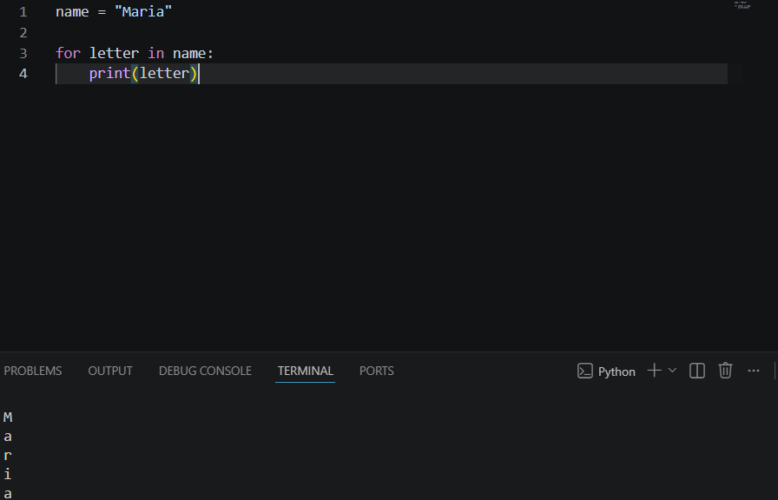
Task 5:
This programme prints even numbers from 2 to 10 by using a custom step value inside a loop.
